### **Team Dynamics Individual Questionnaire**

1. Hello, my name is **Diogo Costa**.
2. My preferred name and pronoun are **Diogo (phonetics: Dee - oh - guu) Pronouns: he / him /his** .
3. My email address is **diogocosta2023@u.northwestern.edu**.
4. My phone number is **8728068265**.
5. My preferred mode of communication is **email if formal, whatsapp or messenger if informal**.
6. I go to bed every day at **10:30 PM**.
7. I normally DO / **DO NOT** pull an all-nighter before a project is due.
8. My worst quality is **that I don’t take unasked advice too well.**
9. If I am being an &*$*%@, please **just say it, I actively try to never be an &*$*%@, even on my worst days, but if you ever perceive me as so, let me know and I’ll immediately address it**.
10. If I am doing good work, **please feel free to mention it, not only because it helps me understand my capacities better (which can be at times hard in the midst of such a talented pool of people), but also because engineer at NU is hard, and I believe that celebrating good work is a good reminder of everyone’s effort and dedication and keeps the general mood and motivation up** .
11. I love **being creative and I absolutely care for a good aesthetic as much as I care for function. Before being an engineer I was a visual artist and worked in the fashion industry for a while, and I carry that in all the work I do**.
12. RDS Skills:
    1. Something that I’m good at and enjoy doing: **ideating, visually communicating and rapid prototyping**.
    2. Something that I’m good at and don’t enjoy doing: **worksheets and logistics**.
    3. Something that I’m not good at but enjoy doing: **physics! I love understanding and applying the principles to real life and to projects, but it just doesn’t come intuitively to me.**
    4. Something that I’m not good at and don’t enjoy doing: **debugging code, especially on a tight schedule**.

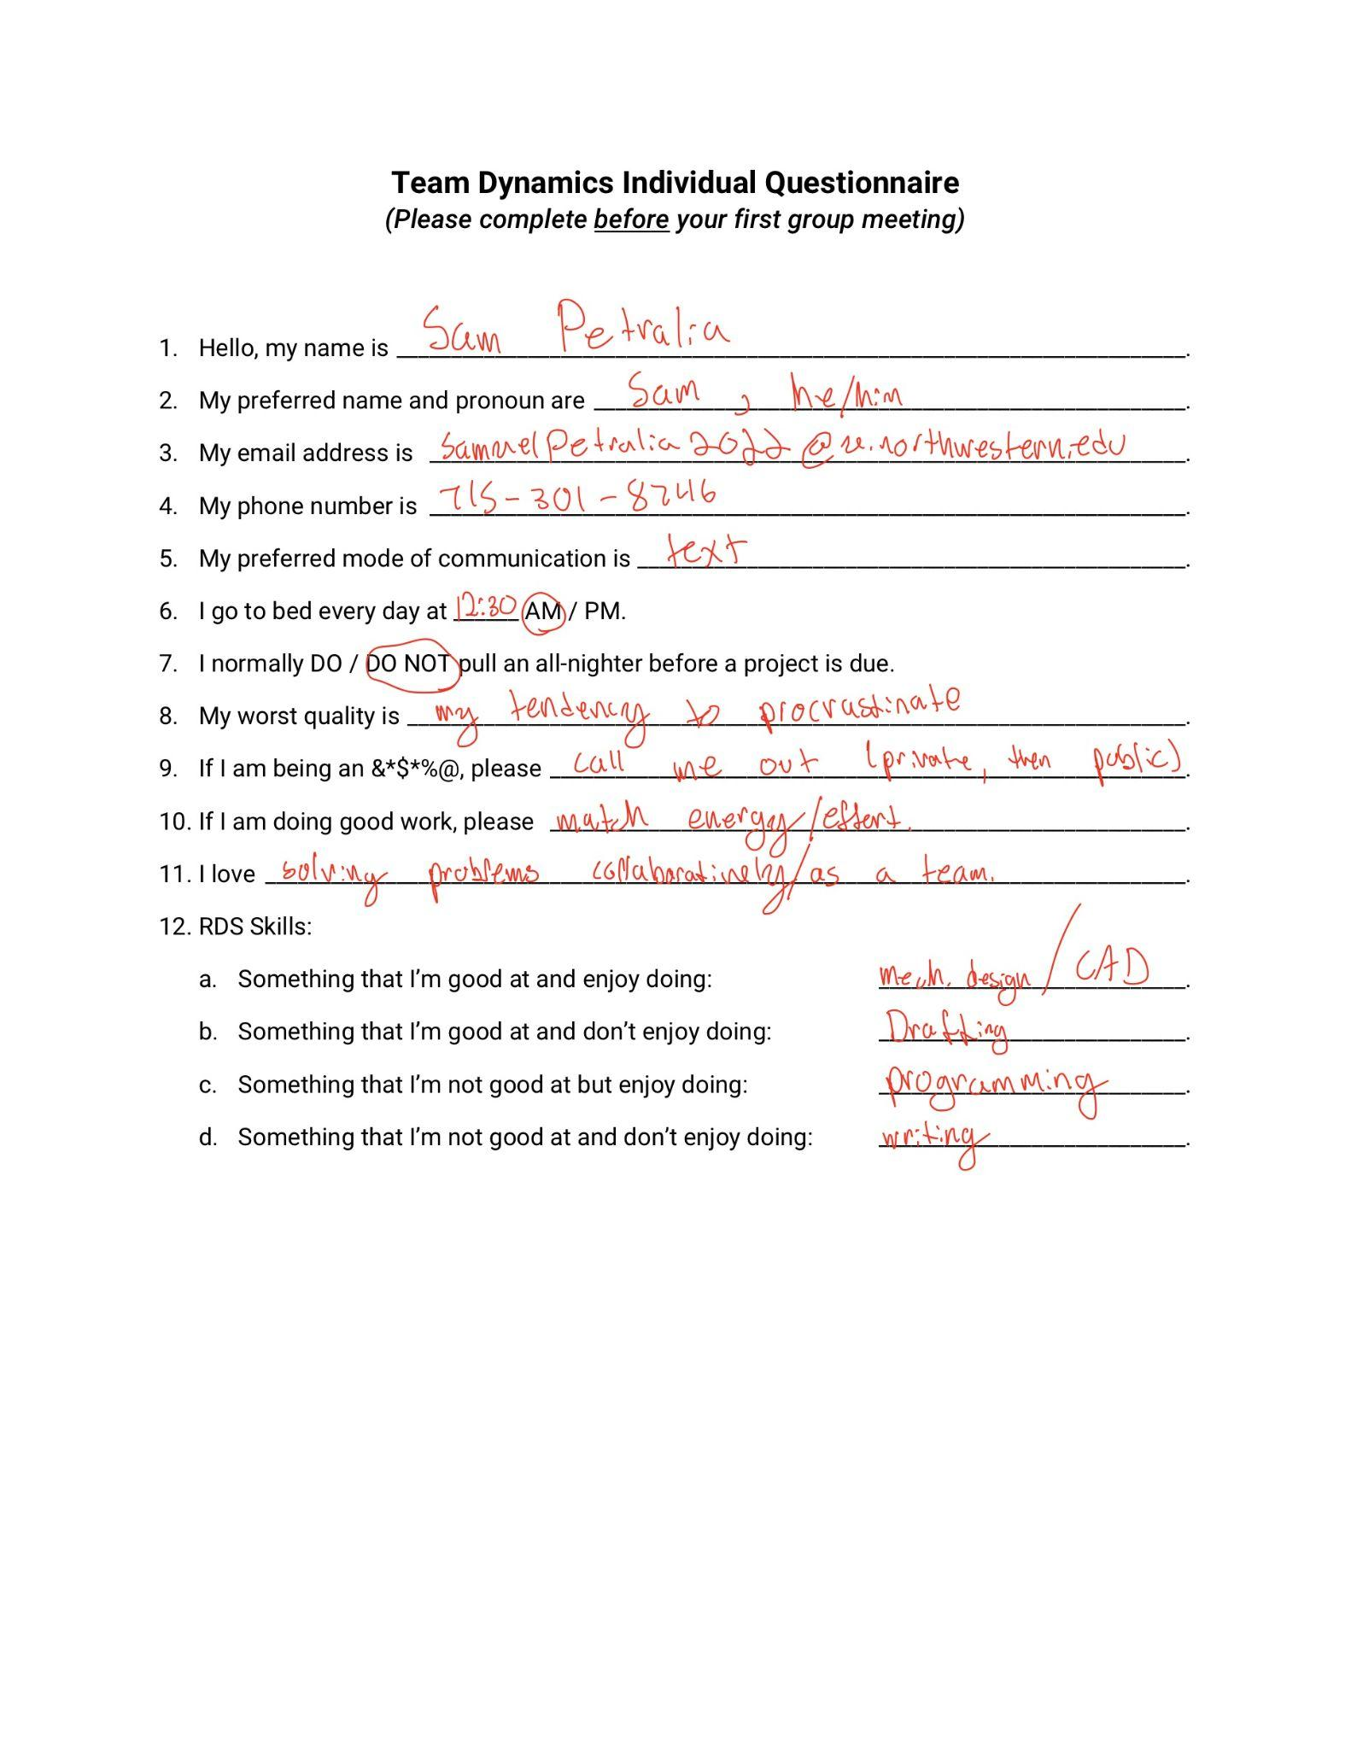

### **Team Dynamics Individual Questionnaire** *(Please complete before your first group meeting)*

1. Hello, my name is Cameron Mastoras.
2. My preferred name and pronoun are ___________Cam, He/him_____________________________.
3. My email address is ___________Cameronmastoras2022@u.northwestern.edu____________________.
4. My phone number is ___________________617-775-7057_________________________.
5. My preferred mode of communication is ________Text_____________.
6. I go to bed every day at 1:30 AM .
7. I normally DO / pull an all-nighter before a project is due.
8. My worst quality is ______I can struggle to let go of failure_____.
9. If I am being an &*$*%@, please ____Tell me I’m being an asshole_____________.
10. If I am doing good work, please __feel free to tell me if my work is good, I really appreciate hearing it________.
11. I love creating things, solving problems, robots, skateboarding__.
12. RDS Skills:
    1. Something that I’m good at and enjoy doing: _CAD, Mech. Design, _____.
    2. Something that I’m good at and don’t enjoy doing: Math______.
    3. Something that I’m not good at but enjoy doing: Tuning PID Loops___.
    4. Something that I’m not good at and don’t enjoy doing: Wiring___.

### **Team Dynamics Individual Questionnaire** *(Please complete before your first group meeting)*

1. Hello, my name is Jose Amador
2. My preferred name and pronoun are He/Him/His
3. My email address is joseamador2022@u.northwestern.edu
4. My phone number is (408)910-2845
5. My preferred mode of communication is Phone/some form of chat
6. I go to bed every day at 1 AM.
7. I normally DO / **DO NOT** pull an all-nighter before a project is due.
8. My worst quality is I feel the need to understand everything
9. If I am being an &*$*%@, please just tell me and I’ll stop
10. If I am doing good work, please Give me a high five
11. I love Going to the gym and staying active from skateboarding to hiking
12. RDS Skills:
    1. Something that I’m good at and enjoy doing: Machining things, I can pretty much use every machine you can think of
    2. Something that I’m good at and don’t enjoy doing: Writing reports and stuff
    3. Something that I’m not good at but enjoy doing: Wiring things up and messing with lots of tiny little components
    4. Something that I’m not good at and don’t enjoy doing: PCB Design, so many things

### 

### **Team Dynamics Individual Questionnaire**

### ***(Please complete before your first group meeting)***

1. Hello, my name is __Yuxuan Liang____________________________________.

2. My preferred name and pronoun are________Lio____(he/him/his)_______________.

3. My email address is_yuxuanliang2021@u.northwestern.edu_______.

4. My phone number is______8729856246__________________________________.

5. My preferred mode of communication is _____messenger, zoom, in-person_________.

6. I go to bed every day at __11__ PM to __2__ AM.

7. I normally _DO_ pull an all-nighter before a project is due.

8. My worst quality is only wanting to spend more time on interesting things.

9. If I am being an &*$*%@, please _ correct my mistakes and stop me asap__.

10. If I am doing good work, please ___Give me a high five______.

11. I love _playing video games, playing basketball ___________________.

12. RDS Skills:

a. Something that I’m good at and enjoy doing: __mechanism design with Math, physics calculation, electronic design (microcontroller coding) _.

b. Something that I’m good at and don’t enjoy doing: __ organize ppt ____________.

c. Something that I’m not good at but enjoy doing: _electronic design (circuit PCB design) _,_presentation__.

d. Something that I’m not good at and don’t enjoy doing: __writing doc___.

### **Team Dynamics Individual Questionnaire**

### ***(Please complete before your first group meeting)***

1. Hello, my name is __Yujui Chen___________________________________________.

2. My preferred name and pronoun are________Ray____(he/him/his)_______________.

3. My email address is_Yu-juichen2023@u.northwestern.edu_______.

4. My phone number is______530-953-1141__________________________________.

5. My preferred mode of communication is _____messenger, zoom, in-person_________.

6. I go to bed every day at __12__ PM to 1 AM.

7. I normally DO pull an all-nighter before a project is due.

8. My worst quality is an easygoing person which everything might take into consideration.

9. If I am being an &*$*%@, please _don’t hesitate to correct my mistakes and stop me__.

10. If I am doing good work, please _ give me an accomplishment or high five_________.

11. I love _scuba diving, free diving, golf and formula one_________________________.

12. RDS Skills:

a. Something that I’m good at and enjoy doing: __programming, design mechanism_.

b. Something that I’m good at and don’t enjoy doing: __Math, physics____________.

c. Something that I’m not good at but enjoy doing: _debugging____.

d. Something that I’m not good at and don’t enjoy doing: __writing doc, design ppt___.

### **Team Culture and Goals Worksheet** *(Please complete as a group during your first group meeting)*

What values are important to your team for a good collaborative environment?

_____Communication ______ ______Asking/giving help early/often________

____Having Fun___________ _______Respect people/time________

_______Stay Positive ______

What are three **technical** goals that you hope to achieve for a **successful final project**?

1. _Everyone learns a new skill_______________________________________________________________
2. __Document process well(as we go)________________________________________________
3. __Keep openness to different design choices_________________________________________

What are three **team** goals that you hope to achieve to ensure a **good collaborative experience**?

1. ___Set and hit reasonable deadlines_____________________________________
2. ___All still friends at the end_______________________________________________________________
3. __ Preserve hanging out outside work____________________________________________________

What specific steps / actions will you take to resolve conflict in your team?

_____Try to solve problem privately before taking it to the whole group. On group decisions, aim for unanimous but if necessary, have at least 4 people agreeing_________________

______________________________________________________________________________________________

What is your team’s procedure for when you cannot resolve a conflict internally?

______Seek out opinion of instructors___________________________________________________

______________________________________________________________________________________________

What will you use for team communications? ______Slack________________________

When and where will your team meet? _____Ford(Sub-Basement) Tuesdays at 5pm____________

How many hours are team members expected to contribute towards RDS each week? _5-15

### **Team Roles** *(Please complete as a group during your first group meeting)*

Team Leader:Cam Responsible for [Leading Meetings, Manage deadlines/project management].

Procurement Lead:Jose Responsible for [procuring necessary components, managing lead times].

Specialists:

Mechanical: Maintaining CAD(Solidworks) quality. Checking over drawings.

Electrical: Lead/consult choosing electrical components. Decide wire color convention, protocol designs, Lead choosing of motors.

Software: Manage github repository. Lead software decisions on overall plan. Make sure code is commented/documented.

Integration: Manage interfaces between other specialists: controllers, encoders, etc. Lead debugging.

Team Leader: ____Cam_____________

Procurement: ____Jose___________________

Specialist __Diogo__ Specialty: _______Mechanical________________

Specialist:Ray Specialty: Electrical_______________________________

Specialist:Lio Specialty: Software _______________________________

Specialist:Sam Specialty: Integration___

